Robot Framework Installation
User Guide

Table of Contents

- Getting started…………………………………………………………………………………1
  - Introduction………………………………………………………………………………..2
  - Tools/Software required………………………………………………………………….4
  - Installation Process……………………………………………………………………….6
Change history

Getting started

Introduction

Robot Framework is a generic test automation framework for acceptance testing and acceptance test-driven development (ATDD). It has easy-to-use tabular test data syntax and it utilizes the keyword-driven testing approach. Its testing capabilities can be extended by test libraries implemented either with Python or Java, and users can create new higher-level keywords from existing ones using the same syntax that is used for creating test cases.

Tools/Software required
This section covers the required tools and preconditions on the operating systems where the test suite is going to be executed. Below is the list of tools/software required for Robot Framework setup:
- Python
- Wxpython
- Pip-Win_1.7
- Robot framework
- RIDE
- Selenium2Library

Installation Process

- Python Installation
Check if python is already installed on your machine or not.

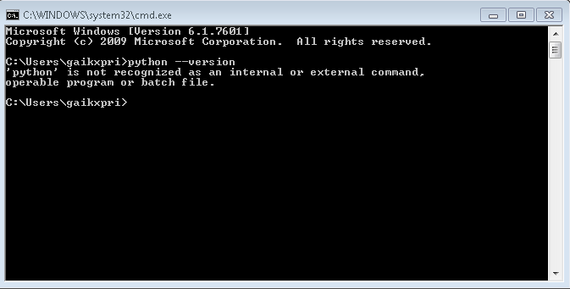

- Install Python version 2.7.6 in your system.
Set Python Path in in environment variable (C:\Python27)
After Python installation and setting python path:

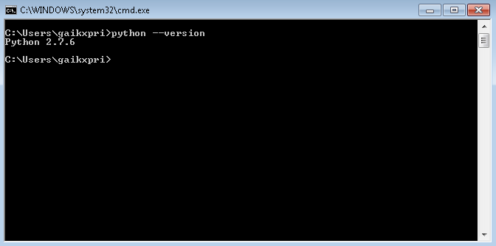

- Install wxpython
- Install pip-Win_1.7
It will automatically provide GUI interface to install and uninstall the packages.
Add the following commands to install the packages:
- For installation of Robot Framework
Type the command: pip install robotframework
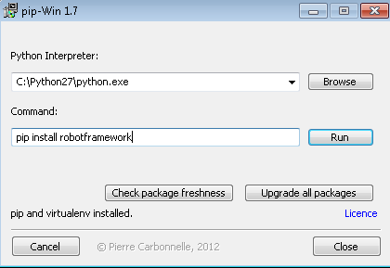

Click on Run
- For installation of RIDE type command: pip install robotframework-ride
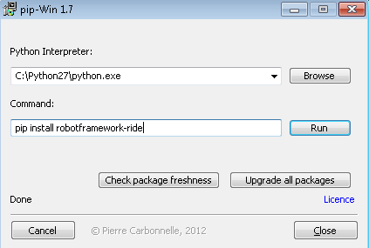

Click on Run

- For installation of Selenium2Library type command: pip install robotframework-selenium2library
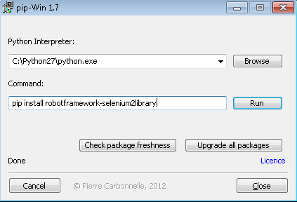

Click on Run

Now, Robot Framework does support both Python 2 and 3. Still they have decided to continue support Python 2 till its available.

Note:-
- If you are using Python 3, pip comes with its setup. Hence no need to install pip additionally for it.
- Option is also available to set PATH for Python 3 setup.

Please find few pip commands for installation of few libraries/modules which are required for the developed Unified TA Framework for Robot Framework.

# Install the latest version
pip install robotframework

Other Commands:-
# Upgrade to the latest version
pip install --upgrade robotframework

# Install a specific version
pip install robotframework==2.9.2

# Install separately downloaded package (no network connection needed)
pip install robotframework-3.0.tar.gz

# Uninstall
pip uninstall robotframework

# Install the latest version of Selenium2Library
pip install robotframework-selenium2library

# Install the latest version of RIDE
pip install robotframework-ride

Change history

Version | Date | Author | Reviewed by | Approved by | Change history
1.0 | 10.31.2017 | Snehal Sawant | Priti Gaikwad |  | Created the document -- Draft Version
1.1 | 03.11.2017 | Priti Gaikwad |  |  | Updated the ALM Integration section

